Tools or Hardware:

1. EFM32 Giant Gecko developer board/ starter Kit (part# EFM32GG-STK3700A) from silicon labs <https://developer.mbed.org/platforms/EFM32-Giant-Gecko/>

This link provides you information regarding Kit and specifications

2. Simplicity studio from silicon labs –

<http://www.silabs.com/products/development-tools/software/simplicity-studio>

This tool is open source software (free) which is IDE for EFM32 Giant gecko developer kit

What we need to do?

**Step-1:** Read signals from Pump and store the data in registers. These signals have continuous stream of fuel prices and error codes.

**Step-2:** Once we store the data we need to perform simple analysis to find out no. of grades on the pump and accordingly determine fuel prices and error codes of each grade

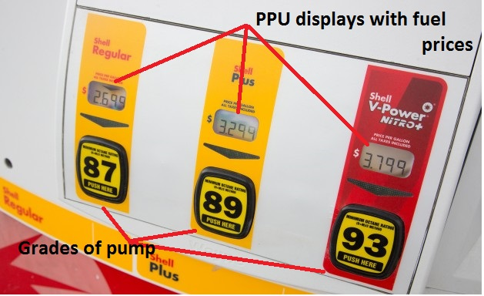

What are our input signals?

**Input signals** include 8 data TTL signals and one clock signal which are coming out of a pump board as shown below and at every rising edge of the clock signal we get data.

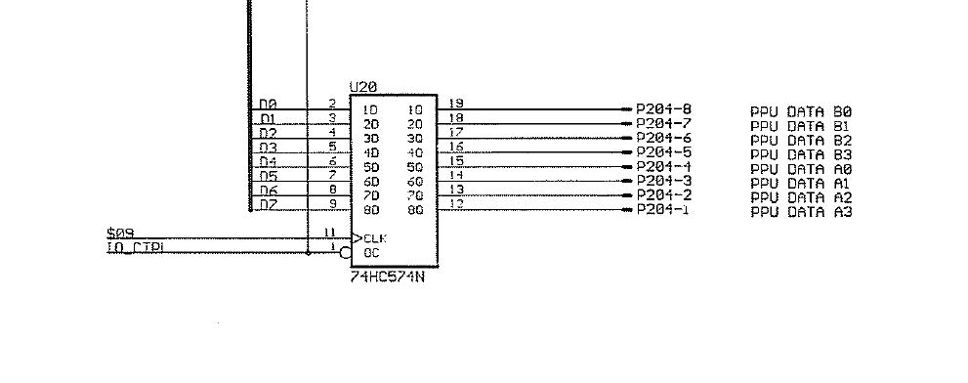

Out of 8 data TTL signals, 4 signals give fuel prices/error codes **(DATA)** and other 4 signals give grade number **(address).**

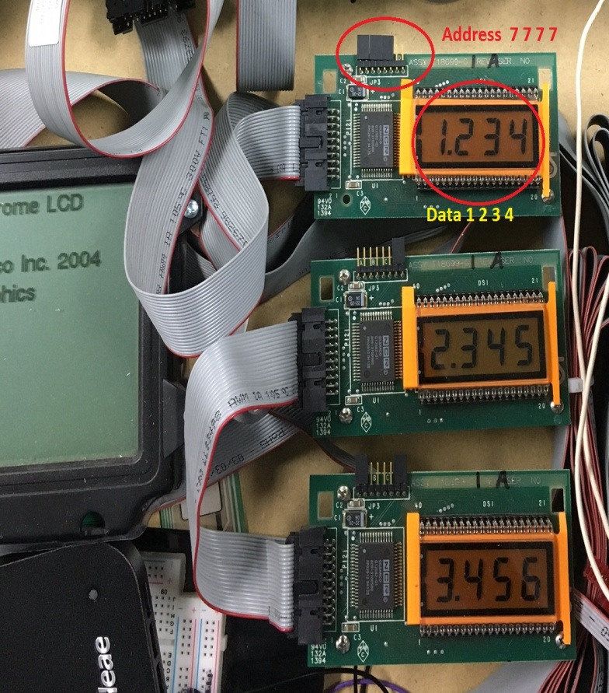

**Picture of PPU with address and Data**

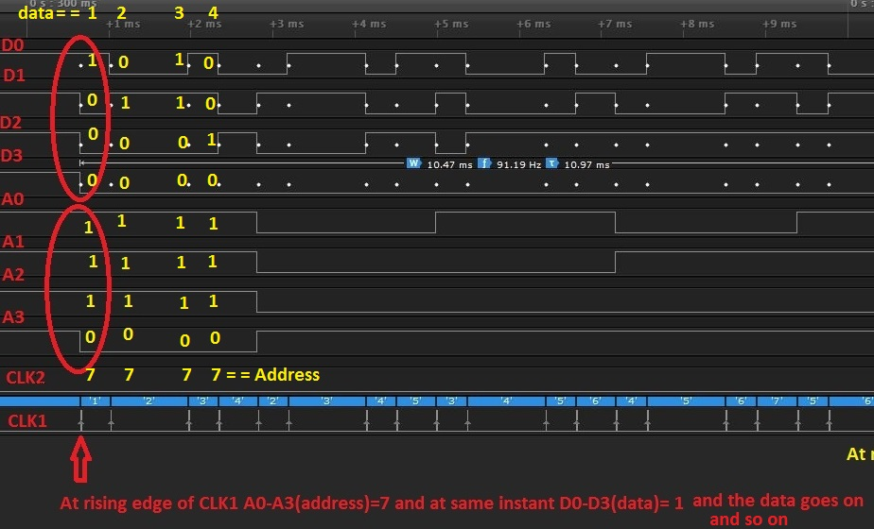

**Signals sample with PPU address and Data**

What would be our First step?

1. Give these signals as inputs to GPIO pins of EFM32 Giant Gecko developer board, read GPIO pins and store the data